ASSIGNMENT - 9
Name: B.Bharath kumar
HT. No: 230351007
Batch: 01

Problem 1:
Consider the following Python function:
def find_max(numbers):
return max(numbers)
Task:
- Write documentation for the function in all three formats:
(a) Docstring
(b) Inline comments
(c) Google-style documentation
- Critically compare the three approaches. Discuss the advantages, disadvantages, and suitable use cases of each style.
- Recommend which documentation style is most effective for a mathematical utilities library and justify your answer.

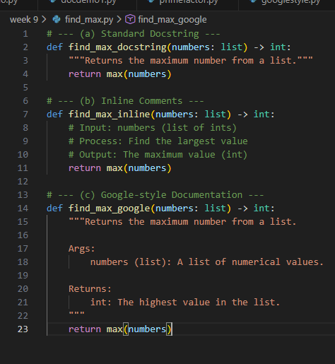

Style | Advantages | Disadvantages | Use Case
Docstring | Easy to read, built-in Python support | Less structured | Small to medium projects
Inline Comments | Very simple | Not suitable for functions | Explaining logic
Google-Style | Professional, standardized | Slightly longer | Libraries & APIs
Google-style documentation is most effective for a mathematical utilities library because it is clear, structured, and widely used in professional projects

Problem 2: Consider the following Python function:
def login(user, password, credentials):
return credentials.get(user) == password
Task:
- Write documentation in all three formats.
- Critically compare the approaches.
- Recommend which style would be most helpful for new developers onboarding a project, and justify your choice
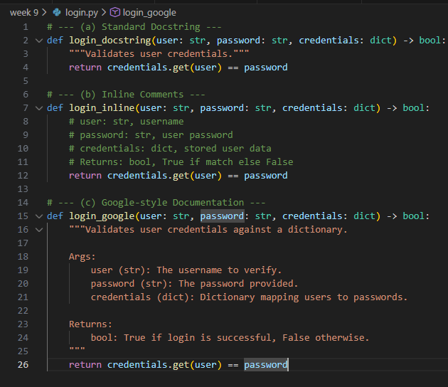
Google-style documentation is best for new developers onboarding because it clearly explain
parameters, return values, and usage.

Problem 3: Calculator (Automatic Documentation Generation)
Task: Design a Python module named calculator.py and demonstrate automatic documentation generation.
Instructions:
- Create a Python module calculator.py that includes the following functions, each written with appropriate docstrings:
  - add(a, b) – returns the sum of two numbers
  - subtract(a, b) – returns the difference of two numbers
  - multiply(a, b) – returns the product of two numbers
  - divide(a, b) – returns the quotient of two numbers
- Display the module documentation in the terminal using Python’s documentation tools.
- Generate and export the module documentation in HTML format using the pydoc utility, and open the generated HTML file in a web browser to verify the output.

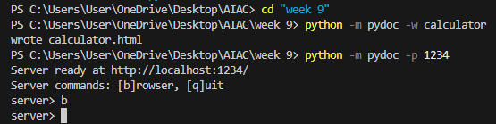

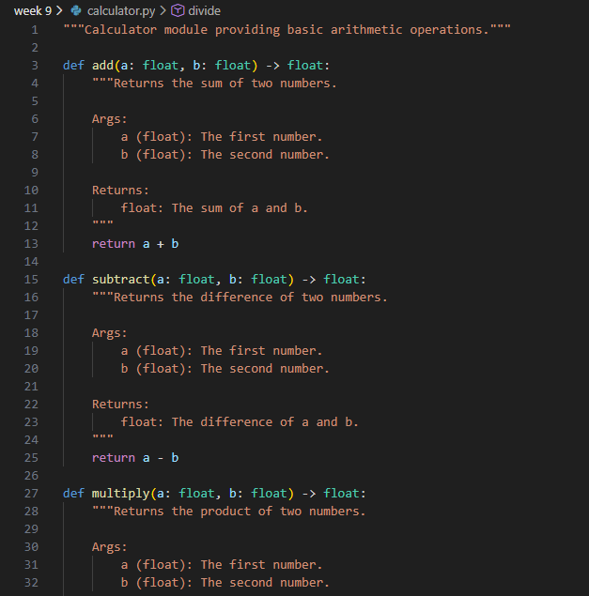

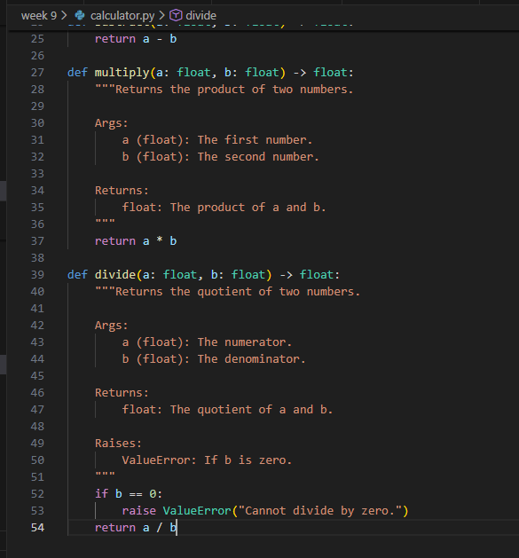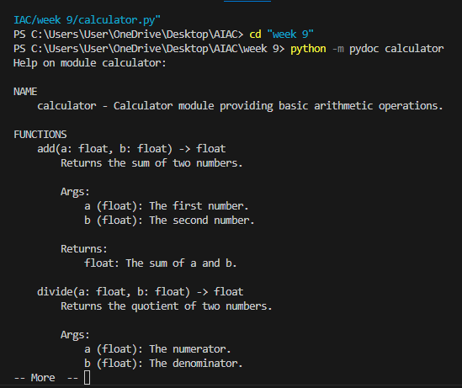
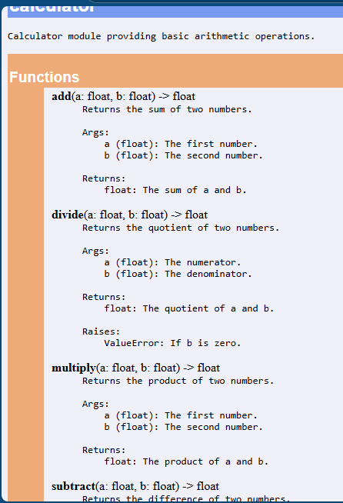
Problem 4: Conversion Utilities Module
Task:
- Write a module named conversion.py with functions:
  - decimal_to_binary(n)
  - binary_to_decimal(b)
  - decimal_to_hexadecimal(n)
- Use Copilot for auto-generating docstrings.
- Generate documentation in the terminal.
- Export the documentation in HTML format and open it in a browser.
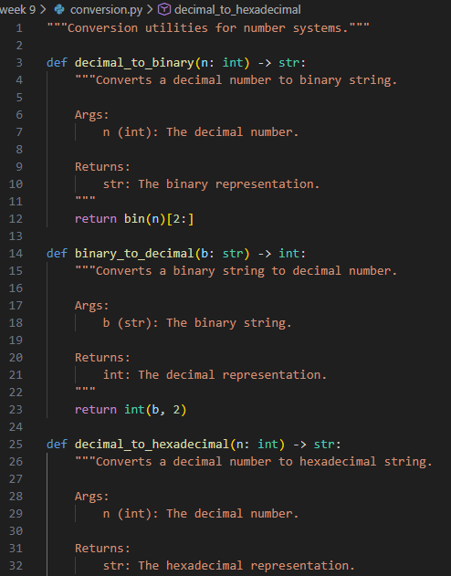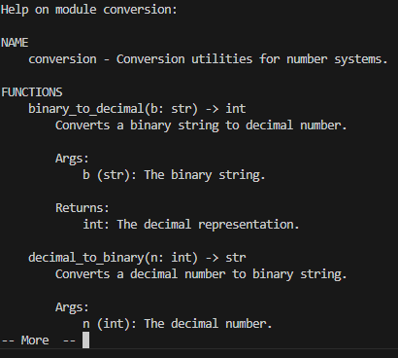

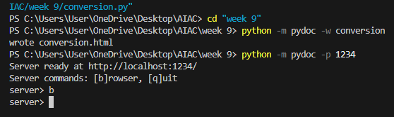
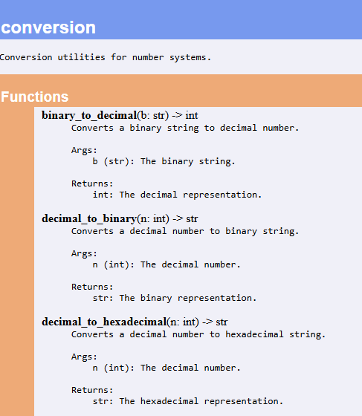
Problem 5 – Course Management Module
Task:
- Create a module course.py with functions:
  - add_course(course_id, name, credits)
  - remove_course(course_id)
  - get_course(course_id)
- Add docstrings with Copilot.
- Generate documentation in the terminal.
- Export the documentation in HTML format and open it in a browser